

***Project Documentation Manual***

**[** **STUDENT MANAGEMENT SCHOOL**]

***SUPERVISOR***

***MAM SEHRISH KHAN***

***SUBMITTED BY***

***RABIA BANO (089322)***

***MISHA TAYYAB (089310)***

***SAVERA NAWAZ (089294)***

***CONTENT:***

Page # 02

1. **Abstract……...………………………………………………….3**
2. **Introduction………………………………………………….3**
3. **Scope…………………………………………………………….….4**
4. **Objectives………………………………………………………4**
5. **Frontend/Backened……………………………………5**
6. **Class Diagram………………………………………….….6**
7. **ERD Diagram………………………………………………7**
8. **Conclusion……………………………………………………..8**
9. **Model Use………………………………………………………8**
10. **Mock-Up…………………………………………………………9**
11. **References…………………………………………………….13**

**ABSTRACT:**

This project helps in school management system. The web application facilitates attendance recording by the teachers, to view status of students by their parents.

The School Management System (SMS) is a software application developed to enhance the efficiency of various functions within a school. The SMS is designed to provide accuracy and timely access to critical information. It helps in decision-making processes of school administrators.

With the implementation of this system, schools can have better management, minimum errors in manual data handling, and improves communication. The SMS is an adaptable solution which is capable of meeting the unique needs of educational institutions with varying times.

**INTRODUCTION:**

The School Management System (SMS) is a digital solution developed to deal with the challenges faced by paper-based management methods. By processes such as student records management, attendance record, and grade reporting digitally, reduces administrative burden and improves overall productivity.

This system helps school administrators to handle student information, attendance and academic performance, all within a centralized database. Additionally, the system facilitates enhanced communication between teachers, students, and parents.

The School Management System is designed as user-friendly website to fulfill the needs of school administrators, teachers, students, and parents. Each user will get advantages of this system, which are designed to support the specific roles within the school environment.

**SCOPE:**

The scope of this project is to handle management and records of staff, reports, attendance and grades. By manipulating this system, school’s administrators can significantly reduce the risk of errors produced with manual data and can improve the accessibility of information.

**OBJECTIVES:**

Here are some well-defined objectives for School Management System (SMS) project:

* To run administrative processes.
* To improve data accuracy and accessibility.
* To enhance communication.
* To support decision-making.
* To ensure data security and privacy.
* To provide user-friendly interfaces.
* To improve resource management.
* To proper adaptability.

**TOOLS FOR FRONTEND/BACKENED:**

While designing the frontend and backend of a School Management System (SMS), several tools and technologies are used depending on the requirements. Below is a list of tools and technologies for both frontend and backend development:

Frontend Development Tools:

* **HTML (Hypertext Markup Language):** The standard language for creating web pages.
* **CSS (Cascading Style Sheets):** Used to style and layout web pages.
* **JavaScript:** A scripting language that enables interactive web features.

Backened Developed Tools:

* **PHP:** A server-side scripting language used to develop dynamic web pages.
* **Xampp Server:** XAMPP plays a crucial role in backend development, especially for web applications. It is a free and open-source cross-platform web server that interpreters for scripts written in PHP.

**CLASS DIAGRAM:**

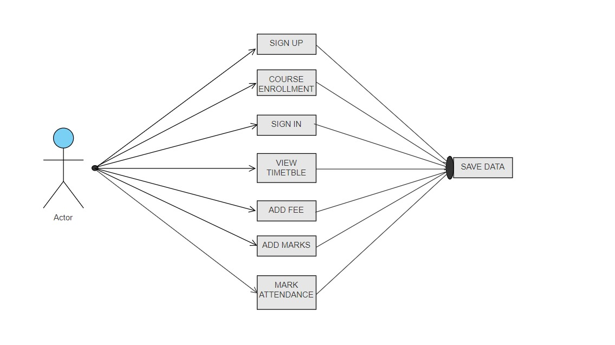

**ER DIAGRAM:**

**Sign In**

**ENROLLMENT**

**SIGN UP**

**ATTENDANCE**

**MARKS**

**Fee**

**CONCLUSION:**

The School Management System (SMS) model has been designed to manage the various functions within a school. By essential components such as student enrollment, fee management, marks, sign-in/sign-up processes, and records of attendance, the model aims to enhance efficiency and data accuracy.

Key Insights:

* Comprehensive data management.
* Enhanced user experience.
* Efficient administrative operations.
* Scalability and flexibility.
* Data integrity and security.

Overall, the SMS model provides a framework for school management and improved administrative functions. Its implementation provides the way for a more organized and responsive educational environment.

**MODEL USE:**

The SMS model provides several practical uses and benefits for educational institutions. Here’s how the model can be effectively utilized:

* Student enrollment system.
* Fee submission.
* Efficient administration.
* Attendance record.
* Sign-In/Sign-Up Management.
* Data Analysis and Reporting.

**MOCK-UP:**

Home Page:

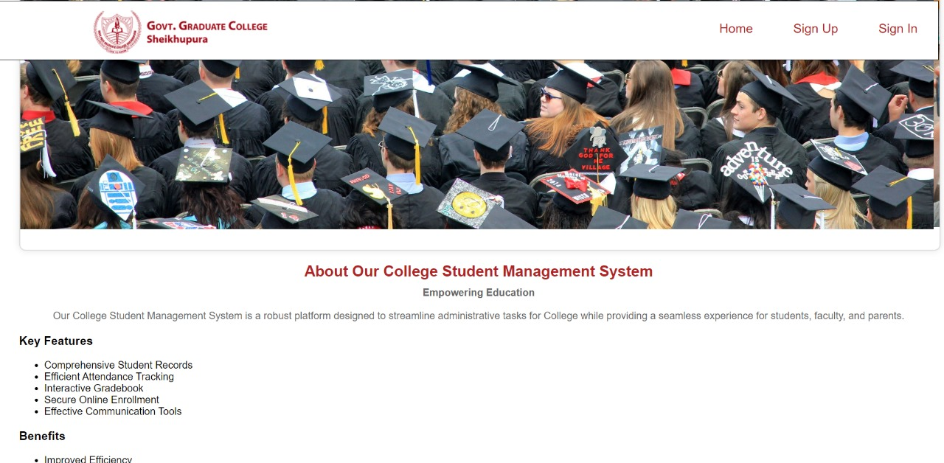

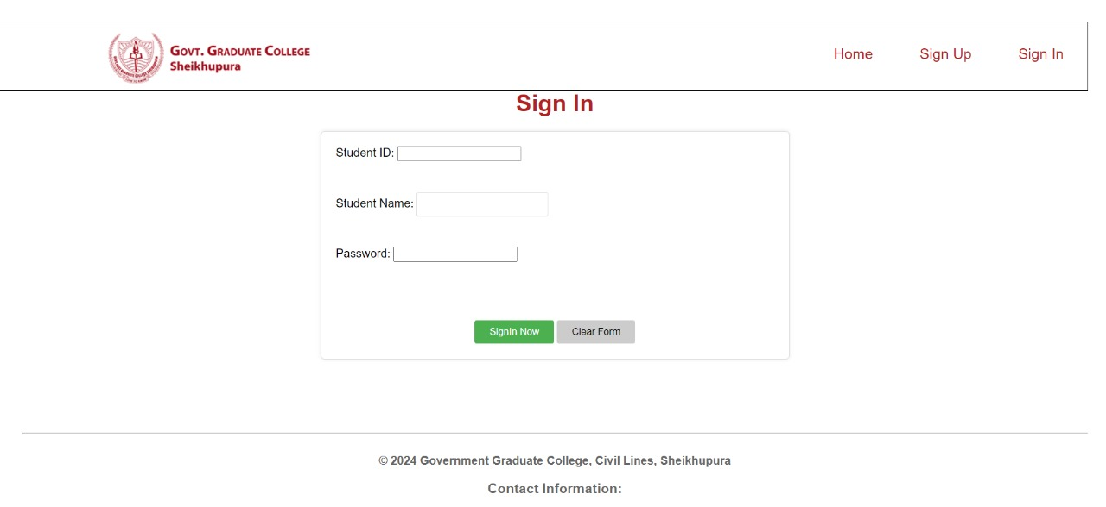Sign in:

Sign Up:

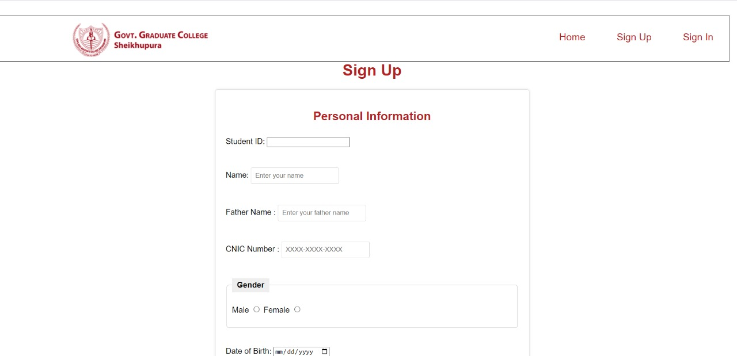

Enrollment:

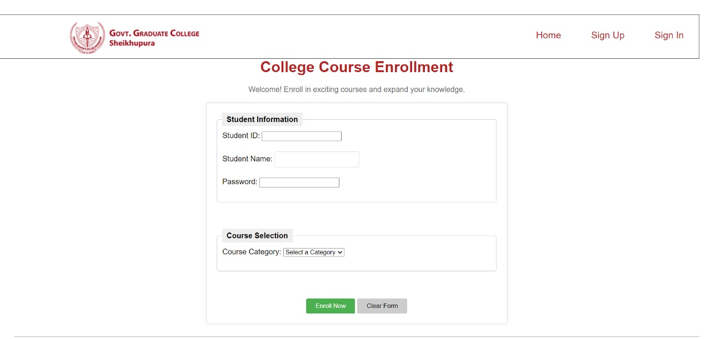

Index Page:

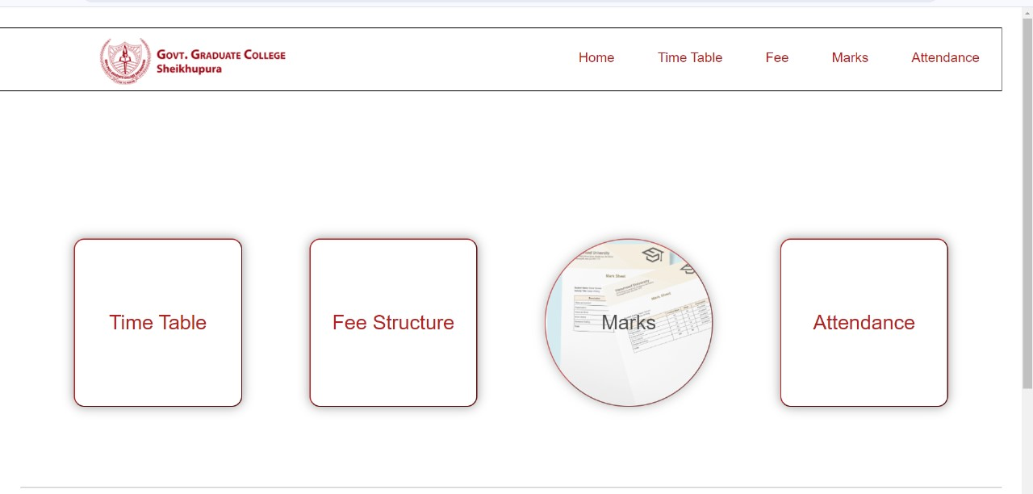

Time Table:

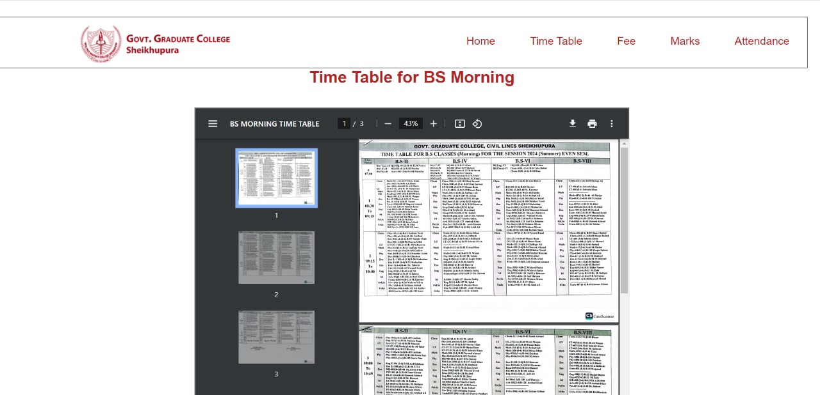

Fee Structure:

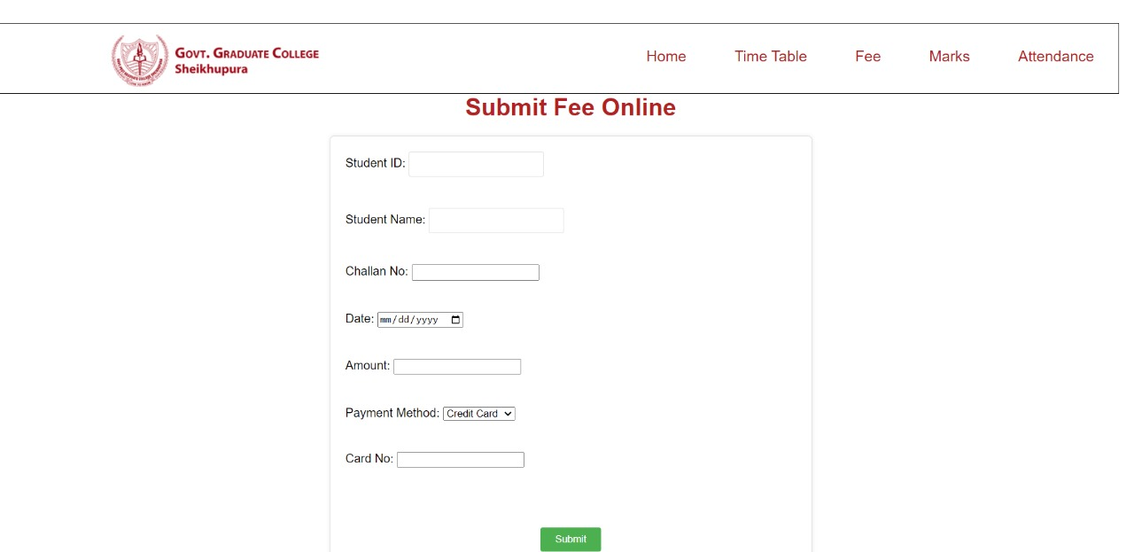

Marks:

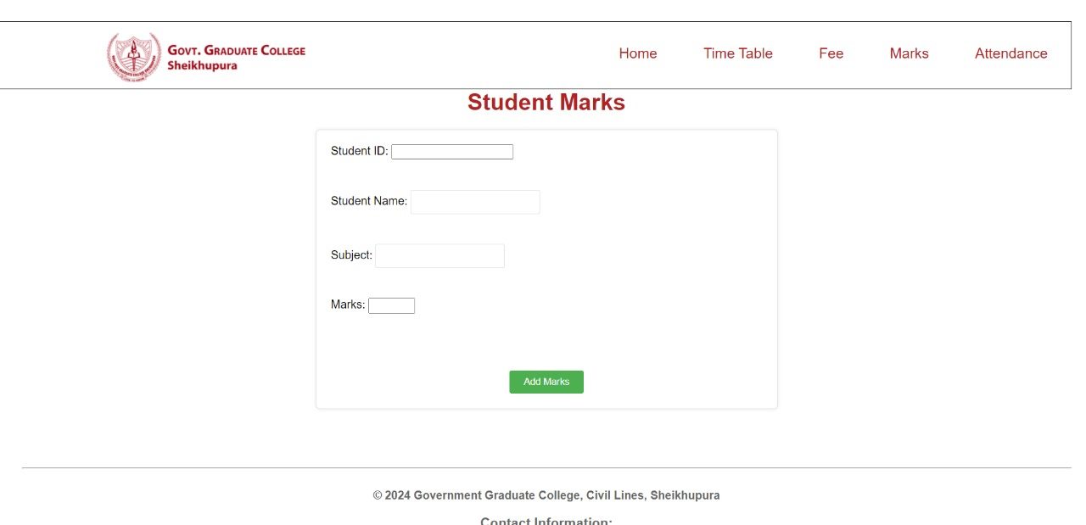

Attendance:

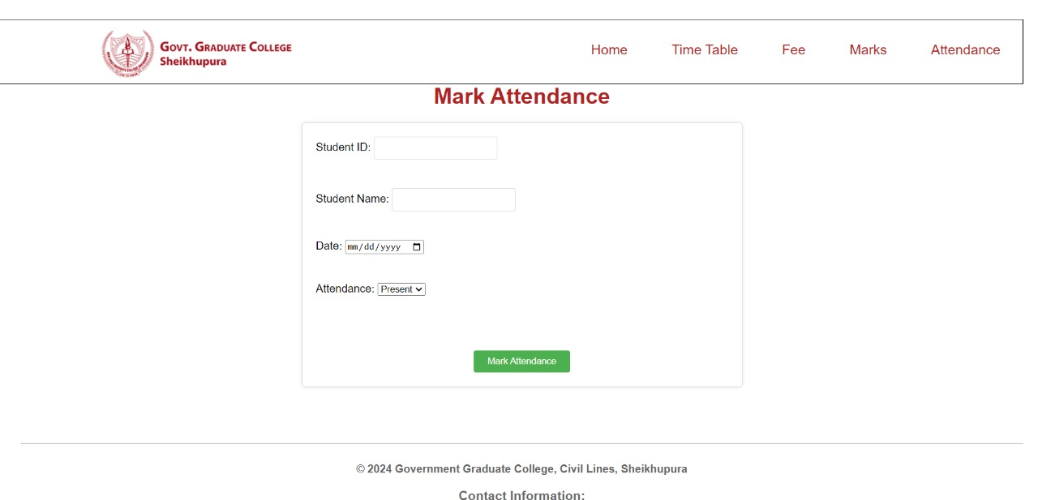

**REFERENCES:**

Websites from Google**:**

* GreekforGreek.org
* ChatGPT.